**Project Deliverable 1 – Project Proposal**

**Faculty Name:** Information Technology

**Module Code:** ITECA3-B12

**Module Name:** Web Development and e-Commerce

**Content Writer:** Kariboba Mpwampu

**Copy Editor:** Mr Kyle Keens

**Submission Date:** Block 1 Week 3

|  |  |
| --- | --- |
| **Student Name** | Lea Thumbiran |
| **Student Number** | LMTPQFTH6 |
| **Project Title** | Lights Out Loadshedding E-Commerce Website |
| **Submission Date** | 17 March 2023 |

**Eduvos**

**Web Development and e-Commerce**

**(ITECA3-B12)**

**Project Deliverable 1**

**Mr. Aruleba. I.**

**Lea Thumbiran LMTPQFTH6  
14 March 2023**

**Table of Contents**

1.1 Introduction 1

1.2 Needs/Problems 1

1.3 Goals/Objectives 2

1.4 Procedures/Scope of Work 3

1.5 Timetable 4

1.6 Budget 8

1.7 Key Personnel 9

1.8 Conclusion 9

1.9 Sign-off 10

Bibliography 11

# Introduction

Load-shedding (the act of turning off one’s power for a certain period due to the failure of not having enough resources to always keep the power on) has been in South Africa since 2007 (Maune, 2019).

With no estimated time in mind for when it will end, many businesses have implemented ways to deal with this ongoing problem.

Currently, businesses employ fuel-based generators, backup power supplies, uninterruptable power supplies (UPS), solar panels and rechargeable lights amongst other things.

But even with their attempts to continue business operations, many businesses struggle to find and purchase these devices at a reasonable price in the first place.

Without being able to purchase these devices and depending on the nature of the business (such as if the business is a factory that manufactures electronics and relies on machinery and power being available most of the time) they may struggle and end up closing as a result.

Lights Out is a new company that sells affordable products to businesses and individuals to deal with the effects of load-shedding.

Currently, they conduct their operations from their physical store.

They wish to expand their operations and to do so they need a database-driven e-commerce website.

# Needs/Problems

* Load-shedding has been implemented since 2007 and is still an ongoing problem (Maune, 2019).
* It is estimated that load-shedding will continue even into the year 2027 (Nyathi, 2022).
* In a national address in 2022 the government stated that they plan to address load-shedding and energy insecurity (Hancke, 2023). The way that they plan to address this is to: fix Eskom, improve the availability of existing supplies, enable, and accelerate private investment in generation capacity and lastly they wish to transform the electricity sector so that they can achieve long-term energy security (Hancke, 2023).
* In addition to this, the government has stated that they plan to minimize the frequency of load-shedding in the country (Kosie, 2023). They plan to do this by adding 3000MW (megawatts) of power from neighbouring countries (Kosie, 2023). This has been successfully implemented and there are more plans to further increase imports from the region (Hancke, 2023).
* As some of these plans were announced recently, it cannot be determined when these plans will be implemented and what impact they may have on the country at this current point in time.
* Load-shedding is currently affecting businesses to a great extent. If a business, for example, supplies fruits, vegetables, and frozen products, they may have to throw out their products if their refrigerators and freezers lose power for a long period of time. This could result in the business running at a loss (Bromhall, 2022). The situation becomes direr if the business, for example, provides a necessary service such as health care, as not having medication at the right temperature or medical equipment not being supplied with power at all times can pose a great risk to people. When the power does return, there is a chance that this surge of power can cause damage to equipment (Bromhall, 2022). Replacing this equipment can become costly very quickly for a business. When power is lost during the day, some businesses are more at risk for theft and burglary, this is due to their security systems not having backup power supplies and therefore being rendered useless (Gustav, 2020).
* Load-shedding is negatively affecting the quality of life of all citizens of South Africa (Igamba, 2023). By not supplying power to the traffic lights on the road, traffic increases and people in turn take longer to go and return from work. It also increases the chances that road accidents occur (Igamba, 2023). People who work online and work remotely (such as working from home) cannot complete their work if their electricity is off. Students who write exams online may not be able to complete their exams if the electricity goes off during the exam. People who suffer from long-term illnesses, such as diabetes may need to have their medication always refrigerated and kept at a certain temperature, however, load-shedding makes this difficult for them (Igamba, 2023).

# Goals/Objectives

* Create a working database-driven e-commerce website to enable customers to purchase products to alleviate the effects of load-shedding.
* Provide videos and documentation to customers on how the load-shedding products can be set up, used, and safely stored away when not in use.
* Provide articles to customers on how they can prolong the lifespan of their electronics when they experience power surges.
* Provide articles to customers on how they can prepare themselves for load-shedding in the future (Fortuin, 2021).
* Improve the reputation of the business by providing a section on the website for customers to communicate with the business and provide their feedback.

# Procedures/Scope of Work

1. **Interview the business/client.**
2. **Develop a project proposal.**
   1. Determine the requirements.
   2. Determine the goals/objectives.
   3. Determine the scope of work and procedures.
   4. Develop a timeline.
   5. Determine the budget.
   6. Identify the key personnel.
3. **Develop documentation and coding:**
   1. Create Class Responsibility Collaborator (CRC) cards.
   2. Create an Enhanced Entity Relationship Diagram.
   3. Create a Data Flow Diagram (DFD).
   4. Create a Use Case Diagram.
   5. Show screenshots of the design of the database.
   6. Develop two prototype websites.
   7. Provide sample code in HTML, CSS, JavaScript, and MySQL.
   8. Select one prototype and fully develop the website.
   9. Add security enhancements to the website.
   10. Host the website and provide a link to the website.
   11. Test the website.
   12. Train users of the system.
4. **Project Presentation:**
   1. Develop a user manual.
   2. Present the website.
5. **Re-submission of all documentation to the supervisor.**

# Timetable

|  |  |  |
| --- | --- | --- |
|  | **Description of Work** | **Start and End Dates** |
| **Deliverable 1** | **Interview the business/client.** | **5 March 2023 – 11 March 2023** |
| **Deliverable 2** | **Develop a project proposal.** | **13 March 2023 – 17 March 2023** |
|  | Determine the requirements. |  |
| Determine the goals/objectives. |
| Determine the scope of work and procedures. |
| Develop a timeline. |
| Determine the budget. |
| Identify the key personnel. |
| **Deliverable 3** | **Develop documentation and coding.** | **18 March 2023 – 7 June 2023** |
|  | Create Class Responsibility Collaborator (CRC) cards. |  |
| Create an Enhanced Entity Relationship Diagram. |
| Create a Data Flow Diagram (DFD). |
| Create a Use Case Diagram. |
| Show screenshots of the design of the database. |
| Develop two prototype websites. |
| Provide sample code in HTML, CSS, JavaScript, and MySQL. |
| Select one prototype and fully develop the website. |
| Add security enhancements to the website. |
| Host the website and provide a link to the website. |
| Test the website. |
| Train users of the system. |
| **Deliverable 4** | **Project Presentation.** | **8 June 2023 – 14 June 2023** |
|  | Develop a user manual. |  |
| Present the website. |
| **Deliverable 5** | **Re-submission of all documentation to the supervisor.** | **15 June 2023 – 21 June 2023** |

*Figure 1-* ***Gantt Chart:*** *Overview with all deliverables* (Roozemond, 2020)

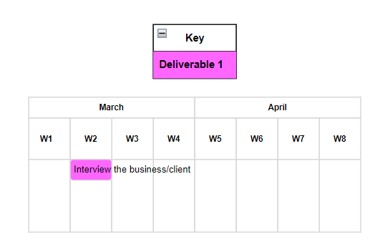

*Figure 2-* ***Gantt Chart: Deliverable 1***

*Figure 3-* ***Gantt Chart: Deliverable 2***

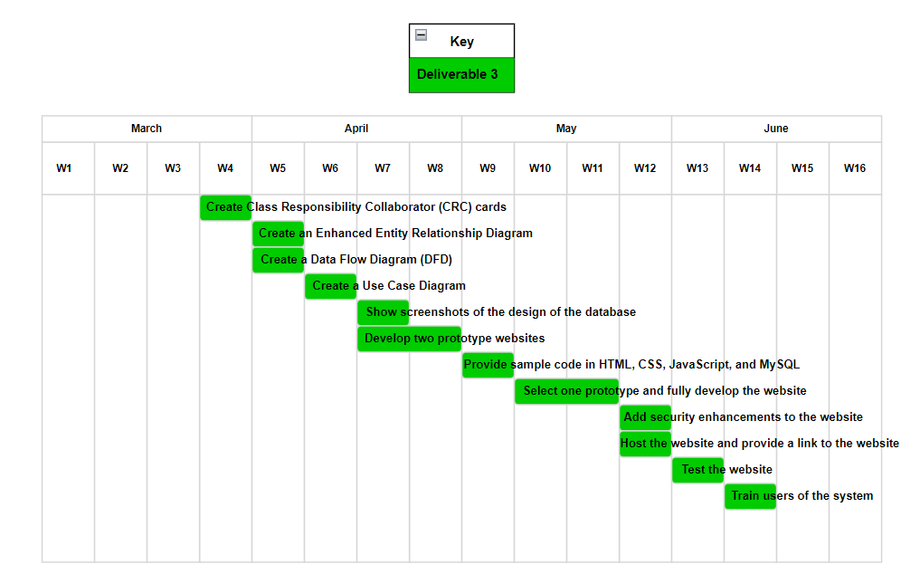

*Figure 4-* ***Gantt Chart: Deliverable 3***

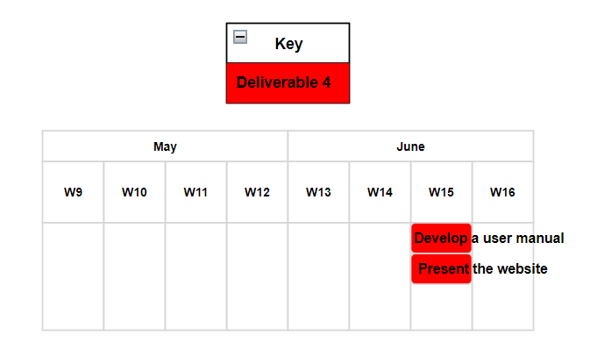

*Figure 5-* ***Gantt Chart: Deliverable 4***

*Figure 6-* ***Gantt Chart: Deliverable 5***

# Budget

|  |  |  |
| --- | --- | --- |
|  | **Description of Work** | **Cost (R)** |
| **Deliverable 1** | **Interview the business/client.** |  |
|  | Fuel  ( Petrol 93 unleaded, 6 litres x R23,16 a litre) | 138,96 |
| **Deliverable 2** | **Develop a project proposal.** |  |
|  | Printing documents  (Black and white ink, 1 to 50 pages, R6 x 5 copies) | 30 |
| **Deliverable 3** | **Develop documentation and coding.** |  |
|  | Hosting website  (R200 x 36 months) (Advertising Solutions Web Design, 2021) | 7 200 |
|  | Printing diagrams  (Black and white ink, 1 to 50 pages, R6 x 10 copies) | 60 |
|  | Printing documentation  (Black and white ink, 1 to 50 pages, R6 x 5 copies) | 30 |
| **Deliverable 4** | **Project presentation.** |  |
|  | Printing business cards  (double sided card: R1,75 x 50 copies) | 87,50 |
|  | Printing posters  (A4 poster: R65 x 2 copies) | 130 |
|  | Printing the user manual  (Black and white ink, 1 to 50 pages, R6 x 10 copies) | 60 |
|  | Renting a webcam  (R500 x 1) | 500 |
|  | Renting a microphone  (R175 x 1) | 175 |
|  | Renting a projector  (R500 x 1) | 500 |
| **Deliverable 5** | **Re-submission of all documentation to the supervisor.** | 0 |
|  | **Total** | **8 911.46** |

# Key Personnel

|  |  |  |
| --- | --- | --- |
| **Stakeholders** | **Name [and Company]** | **Contact Details** |
| Client | Sean Smith [Lights Out] | seansmith23lightsout@mail.com |
| Supervisor | Idowu Aruleba [Eduvos] | idowu.aruleba@eduvos.com |
| Developer/ Project manager | Lea Thumbiran [Eduvos] | lmtpqfth6@vossie.net |

# Conclusion

Lights Out is a company that sells products to businesses and individuals to deal with the effects of loadshedding. They wish to expand their operations and have requested that a database driven e-commerce website should be developed. The website is expected to be completed by 14 June 2023.

# Sign-off

|  |  |  |  |
| --- | --- | --- | --- |
|  |  |  |  |
| Sean Smith,  Project Client    Date: 2023-03-16 |  |  | Lea Thumbiran, Developer/Project Manager    Date: 2023-03-16 |

# Bibliography

Advertising Solutions Web Design, 2021. *How Much Does a Website Design Cost in South Africa? [2023] | Web Design Prices.* [Online] Available at: https://advertisingsolutions.co.za/website-design-cost-south-africa/#:~:text=The%20cost%20of%20hosting%20a%20website%20in%20South,hosting%20or%20VPS%20hosting%2C%20can%20cost%20significantly%20more.[Accessed 16 March 2023].

Asana., 2022. *Scope of Work vs. Statement of Work: The Differences • Asana*. [Online] Asana. Available at: https://asana.com/resources/scope-work-vs-statement-work [Accessed 14 Mar. 2023].

Bridges, J., 2020. *How to Write a Scope of Work*. [Online] ProjectManager.com. Available at: https://www.projectmanager.com/training/write-scope-work [Accessed 16 Mar. 2023].

Bromhall, M., 2022. *How Load-shedding Affects Small Businesses.* [Online] Available at: https://smesouthafrica.co.za/how-load-shedding-affects-small-businesses/[Accessed 14 March 2023].

Fortuin, J., 2021. *Load-shedding: 10 products to make your life easier.* [Online] Available at: https://www.bloemfonteincourant.co.za/load-shedding-10-products-to-make-your-life-easier/#:~:text=Load-shedding%3A%2010%20products%20to%20make%20your%20life%20easier,impossible%20without%20a%20gas%20stove%20or%20cooker.%20[Accessed 14 March 2023].

Gustav, 2020. *How Does Load Shedding Impact your Business?.* [Online] Available at: https://generatorparts.co.za/how-does-load-shedding-impact-your-business/[Accessed 14 March 2023].

Hancke, H., 2023. *This is what government says it has done to combat load-shedding.* [Online] Available at: https://www.timeslive.co.za/news/south-africa/2023-01-21-this-is-what-the-government-says-it-has-done-to-combat-load-shedding/[Accessed 14 March 2023].

Igamba, J., 2023. *How Eskom & The Government Can Put An End To Loadshedding in South Africa.* [Online] Available at: https://www.greenpeace.org/africa/en/blogs/53187/how-the-government-eskom-can-put-an-end-to-load-shedding/[Accessed 14 March 2023].

Kosie, H., 2023. *SONA 2023: South Africa's Energy Crisis Is The Main Concern.* [Online] Available at: https://www.skillsportal.co.za/content/sona-2023-south-africas-energy-crisis-main-concern  
[Accessed 14 March 2023].

Laudon, K.C. and Traver, C.G., 2021. *E-commerce : business, technology, society*. 16th ed. Harlow, England ; New York: Pearson.

Maune, B., 2019. *Load shedding: Timeline of Eskom’s battle to keep the lights on.* [Online] Available at: https://www.thesouthafrican.com/news/eskom-load-shedding-timeline-since-2007/  
[Accessed 14 March 2023].

Nixon, R., 2021. *LEARNING PHP, MYSQL & JAVASCRIPT : a step-by-step guide to creating dynamic websites.* 6th ed. S.L.: O’reilly Media.

Nyathi, M., 2022. *‘Load-shedding will continue until 2027’.* [Online] Available at: https://mg.co.za/news/2022-11-09-load-shedding-will-continue-until-2027/[Accessed 14 March 2023].

Prior, B., 2020. *How much it costs to build and host a website in South Africa*. [Online] Mybroadband.co.za. Available at: https://mybroadband.co.za/news/cloud-hosting/361313-how-much-it-costs-to-build-and-host-a-website-in-south-africa.html [Accessed 16 Mar. 2023].

Roozemond, B., 2020. *Increase productivity with Gantt charts in draw.io.* [Online] Available at: https://drawio-app.com/blog/increase-productivity-with-gantt-charts-in-draw-io/  
[Accessed 15 March 2023].

Simmons, M., 2021. *How to Write a Project Proposal (Steps & Template Included)*. [Online] ProjectManager.com. Available at: https://www.projectmanager.com/blog/how-to-create-a-project-proposal [Accessed 16 Mar. 2023].